Infinitive Subject

✅ What is Infinitive Subject
# Source: AI Source: Provided by: [Data Path: Persons Table -> ID Column: 1, Name_En Column: Motasem Essam] -> From: [Chatgpt (GPT-4-turbo)] on [8/4/2025]
An infinitive subject is a verb in the base form preceded by "to" (i.e., an infinitive) that functions as the subject of a sentence.
An infinitive = "to" + base verb (e.g., to run, to eat, to learn)

🔹 Key Features:
# Source: AI Source: Provided by: [Data Path: Persons Table -> ID Column: 1, Name_En Column: Motasem Essam] -> From: [Chatgpt (GPT-4-turbo)] on [8/4/2025]
- Acts as a noun.
- Performs the function of the subject in a sentence.
- Often expresses actions, intentions, or general truths.
- Verb usually agrees in singular form with the infinitive.

🔹 Examples of Infinitive Subjects:
# Source: AI Source: Provided by: [Data Path: Persons Table -> ID Column: 1, Name_En Column: Motasem Essam] -> From: [Chatgpt (GPT-4-turbo)] on [8/4/2025]
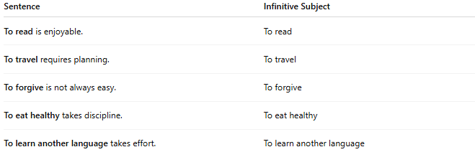
Sentence | Infinitive Subject
To read is enjoyable. | To read
To travel requires planning. | To travel
To forgive is not always easy. | To forgive
To eat healthy takes discipline. | To eat healthy
To learn another language takes effort. | To learn another language

🔍 Infinitive vs. Infinitive Phrase:
# Source: AI Source: Provided by: [Data Path: Persons Table -> ID Column: 1, Name_En Column: Motasem Essam] -> From: [Chatgpt (GPT-4-turbo)] on [8/4/2025]
- Infinitive Subject: To sleep is important.
- Infinitive Phrase Subject: To sleep early during the week is important.
The infinitive phrase includes the infinitive plus modifiers or complements.

